Day 1:

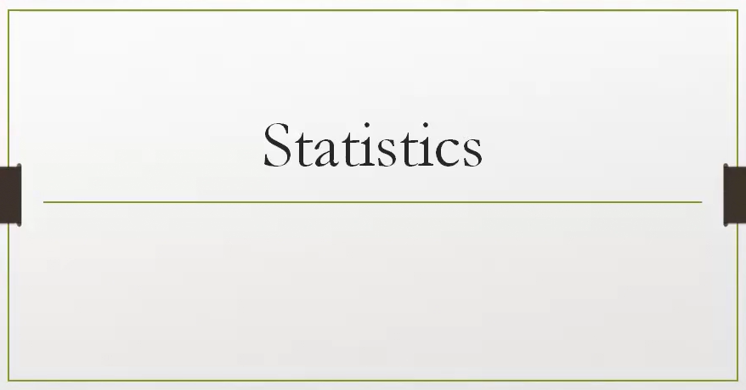

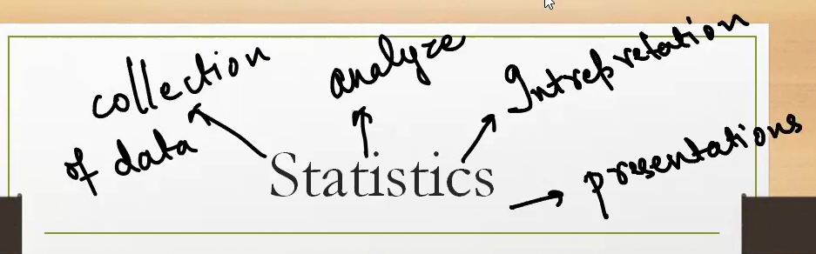

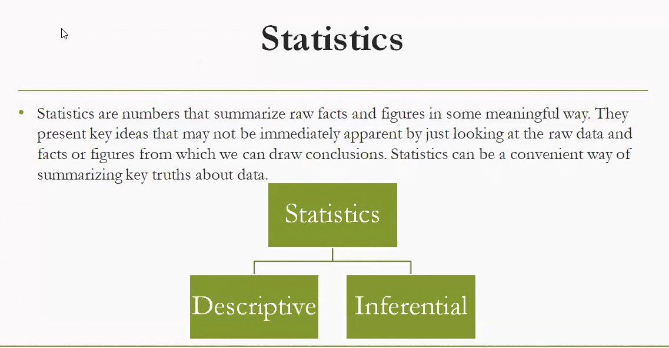

**What Are Statistics?**

“Statistics are numbers that summarize raw facts and figures in some meaningful way.”

They help us:

* Understand patterns
* Make decisions
* Communicate insights clearly

**🌿 Real-Time Example: School Exam Results**

Imagine a school collects scores from 500 students in a math exam.

**1. Descriptive Statistics**

These summarize the data **without making predictions**.

* **Mean score**: 72.5
* **Median score**: 75
* **Standard deviation**: 8.2
* **Histogram**: Shows most students scored between 70–80

✅ **Purpose**: Describe what happened in the dataset.

**2. Inferential Statistics**

These use the data to **make predictions or generalizations** about a larger group.

* The school wants to know: *“Will next year’s students perform similarly?”*
* They take a **random sample of 50 students** and analyze their scores.
* Using **confidence intervals**, they estimate the average score for all future students.
* They might run a **hypothesis test**: “Is the new teaching method improving scores?”

✅ **Purpose**: Draw conclusions beyond the data you have.

**🧠 Summary Table**

| **Branch** | **What It Does** | **Example Use Case** |
| --- | --- | --- |
| Descriptive | Summarizes data | Mean, median, charts of exam scores |
| Inferential | Predicts or tests hypotheses | Estimating future performance, testing methods |

**Inferential statistics use sample data to make predictions or generalizations about a larger population. It goes beyond describing data and helps answer questions like “What might happen?” or “Is this effect real?”**

**🧠 What Is Inferential Statistics?**

Inferential statistics is the branch of statistics that allows us to:

* **Draw conclusions** about a population based on a sample.
* **Test hypotheses** to see if observed patterns are statistically significant.
* **Estimate parameters** like population mean or proportion.
* **Predict future outcomes** using models.

It relies heavily on **probability theory** to measure uncertainty and confidence in conclusions.

**🔍 Key Techniques in Inferential Statistics**

| **Technique** | **Purpose** | **Example Use Case** |
| --- | --- | --- |
| **Hypothesis Testing** | Test if a claim about a population is true | Is a new drug more effective than the old one? |
| **Confidence Intervals** | Estimate a range for a population parameter | What’s the likely average height of Indian men? |
| **Regression Analysis** | Model relationships between variables | How does income affect spending habits? |
| **ANOVA (Analysis of Variance)** | Compare means across multiple groups | Do three teaching methods yield different results? |
| **Chi-Square Tests** | Test relationships between categorical variables | Is there a link between gender and voting preference? |

**📊 Real-Life Example**

**Scenario**: A company wants to know if a new training program improves employee productivity.

* They randomly select **50 employees** and measure their productivity before and after training.
* Using **hypothesis testing**, they check if the improvement is statistically significant.
* If the result passes a significance threshold (e.g., p-value < 0.05), they conclude the training likely works for the entire workforce.

This is **inferential** because they’re making a **generalization** from a **sample** to a **population**.

**⚖️ Descriptive vs. Inferential**

| **Feature** | **Descriptive Statistics** | **Inferential Statistics** |
| --- | --- | --- |
| Focus | Summarizing data | Drawing conclusions from data |
| Based on | Entire dataset | Sample from a population |
| Output | Charts, means, medians | Predictions, confidence intervals |
| Example | Average score of 50 students | Estimating average score of all students |

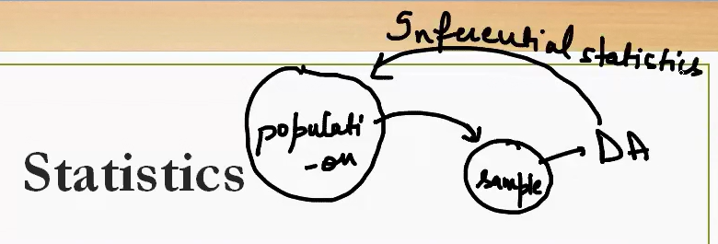

This diagram beautifully captures the **core idea of inferential statistics**: using a **sample** to make conclusions about a **population**.

**📊 Key Elements in the Diagram**

* **Population**: The full group you're interested in studying (e.g., all voters in India, all customers of a company).
* **Sample**: A smaller, representative subset of the population (e.g., 1,000 surveyed voters, 500 customers).
* **DA (Data Analysis)**: You analyze the sample data — calculate means, proportions, trends.
* **Inferential Statistics**: You use the results from the sample to **infer or predict** characteristics of the entire population.

**🧠 Real-Time Example: Election Polling**

Imagine you're trying to predict the outcome of a national election:

1. **Population**: All eligible voters in India.
2. **Sample**: You survey 10,000 randomly selected voters.
3. **Data Analysis (DA)**: You find that 58% of your sample supports Candidate A.
4. **Inferential Statistics**: You estimate that **around 58% of the entire population** may support Candidate A — with a margin of error and confidence level.

This is **inference**: you're not just describing the sample, you're **drawing conclusions about the whole**.

**🔁 Feedback Loop**

The arrow from sample back to population labeled “Inferential statistics” shows this leap:

* You **don’t need to measure everyone**.
* You **use probability and sampling theory** to generalize from the few to the many.
* You move the conclusion from Descriptive to Inferential.
* Based on Descriptive you will give final results/prediction using Inferential.
* For example : Covid vaccine application Using Inferential for larger population.

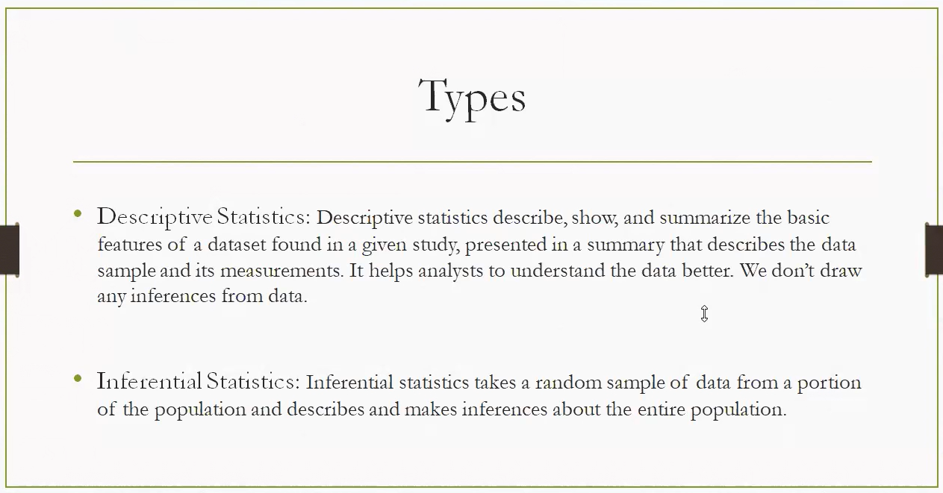

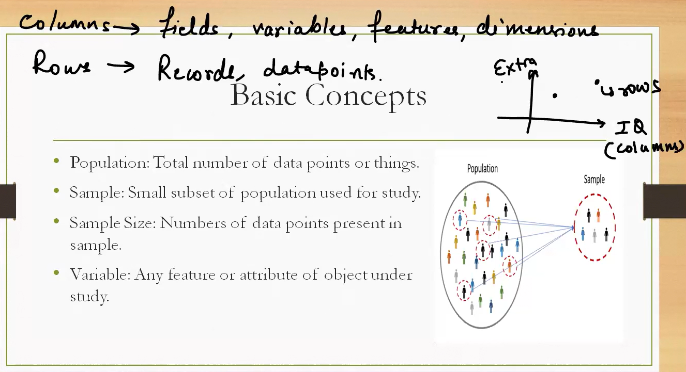

**Key Concepts Explained**

**🔹 Population**

* The **entire group** you're interested in studying.
* Example: All citizens of India, all customers of Amazon, or all students in a university.

**🔹 Sample**

* A **subset** of the population selected for analysis.
* Example: 1,000 surveyed citizens, 500 Amazon customers, or 100 students from one department.

**🔹 Sample Size**

* The **number of data points** in the sample.
* Example: If you survey 100 students, your sample size is 100.

**🔹 Variable**

* A **feature or attribute** being measured.
* Example: Age, income, IQ, height, exam score.

**📊 Data Structure: Rows and Columns**

* **Columns** = Variables, Features, Fields (e.g., Age, Gender, Salary)
* **Rows** = Records, Data Points (e.g., Person A, Person B)

Think of a spreadsheet:

* Each **row** is a person.
* Each **column** is a trait.

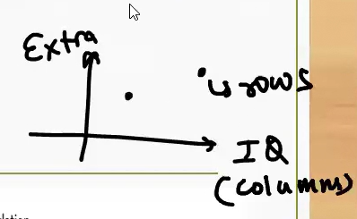

**What’s Being Shown**

* **IQ (columns)**: This is the independent variable — a feature or attribute like intelligence score.
* **Extra**: This could represent an outcome or another trait — perhaps "extra effort," "extra performance," or "extra credit."
* **Data Points**: Each dot represents an individual record (a person, observation, or case).
  + One point is labeled **"some"**, indicating a person with higher IQ but lower "Extra".
  + Another point is closer to the origin but higher on "Extra", suggesting someone with lower IQ but higher "Extra".

**🧠 What Can We Infer for a particular person like Tushar, Sachin?**

* This plot may be exploring whether **IQ correlates with Extra**.
* If more points follow a pattern (e.g., higher IQ → higher Extra), it suggests a **positive correlation**.
* If the pattern is scattered or reversed, it might show **no correlation** or a **negative one**.

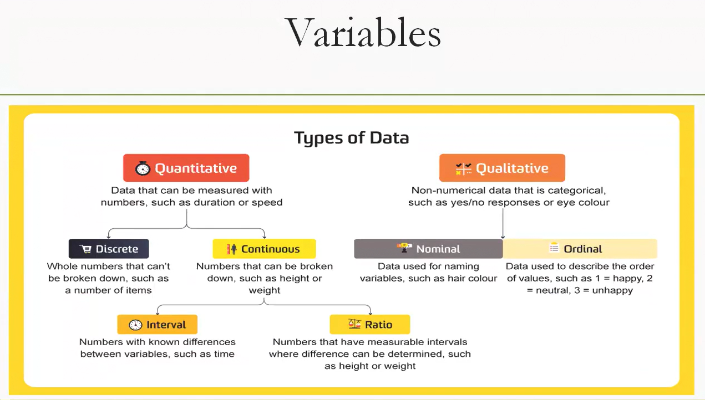

This diagram breaks down the **types of variables** used in statistics and data analysis, helping you understand how to classify and handle different kinds of data. Let’s explore each category with clear definitions and real-world examples:

**🔢 Quantitative Variables**

These are **numerical** and can be measured.

**1. Discrete**

* **Definition**: Whole numbers; countable items.
* **Examples**: Number of students in a class, goals scored in a match, books on a shelf.

**2. Continuous**

* **Definition**: Can take **any value within a range**, including decimals.
* **Examples**: Height (e.g., 172.5 cm), weight (e.g., 65.3 kg), temperature.

**🔸 Subtypes of Continuous:**

* **Interval**
  + **Definition**: Numeric values with equal spacing, but **no true zero**.
  + **Examples**: Time of day (e.g., 2 PM vs 4 PM), temperature in Celsius.
* **Ratio**
  + **Definition**: Numeric values with equal spacing **and a true zero**.
  + **Examples**: Height, weight, income, age.

**🔤 Qualitative Variables**

These are **non-numerical** and describe categories.

**1. Nominal**

* **Definition**: Labels or names without any order.
* **Examples**: Hair color (black, brown, blonde), city names, blood type.

**2. Ordinal**

* **Definition**: Categories with a **meaningful order**, but no fixed spacing.
* **Examples**: Customer satisfaction (happy, neutral, unhappy), education level (high school, college, graduate).

**🧠 Why This Matters**

* Choosing the right variable type affects:
  + **Which statistical tests** you can use.
  + **How you visualize data** (bar chart vs histogram).
  + **How you interpret results** (ranking vs measurement).

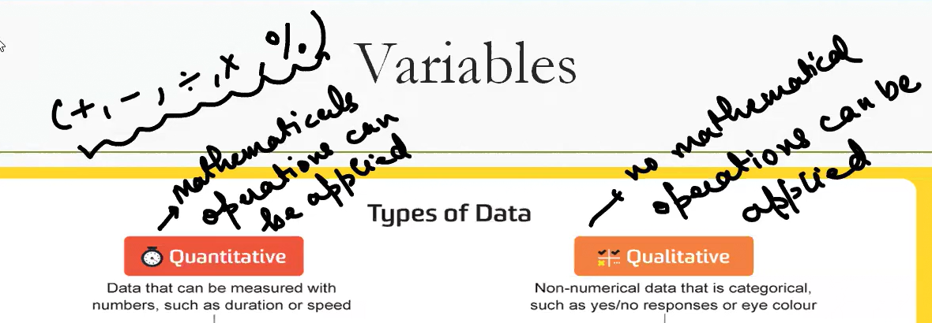

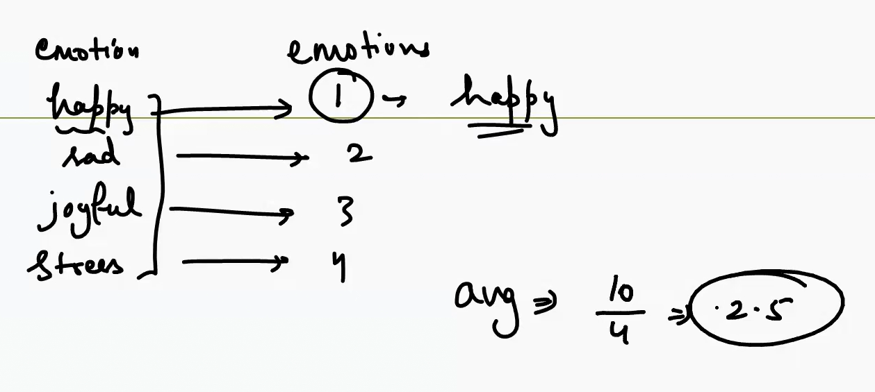

No meaning of mathematical operation here Qualitative Variable here.

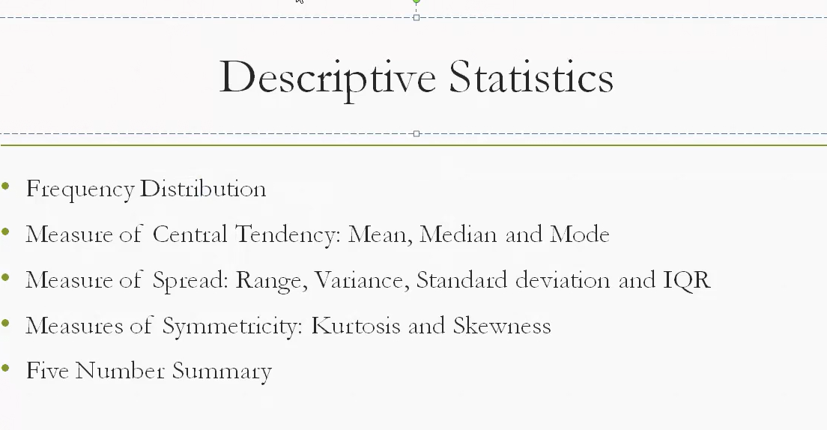

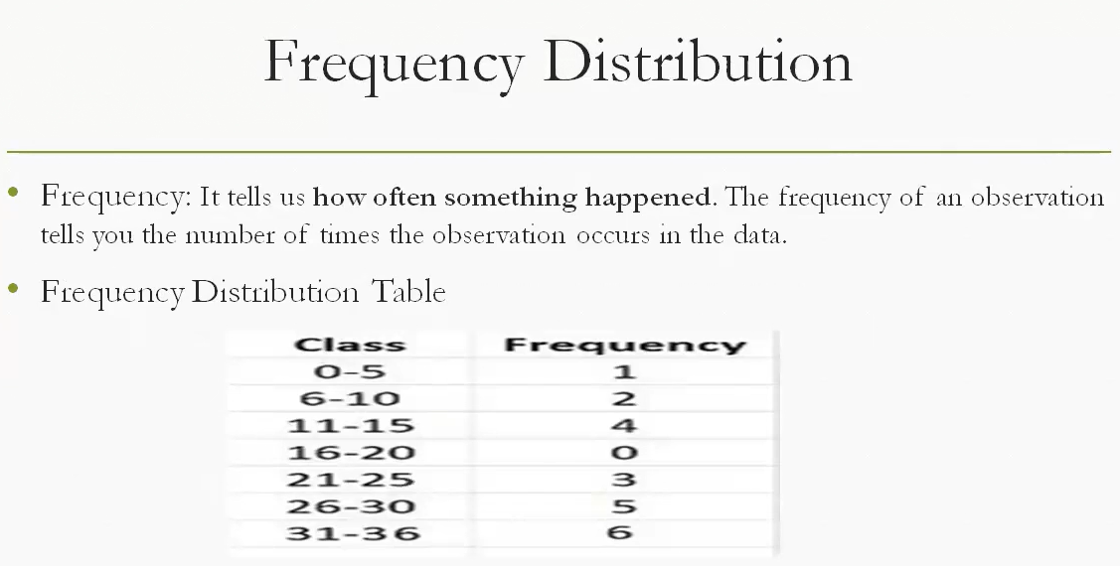

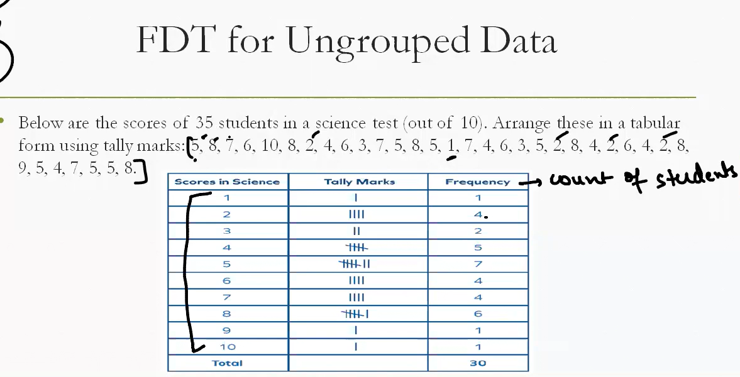

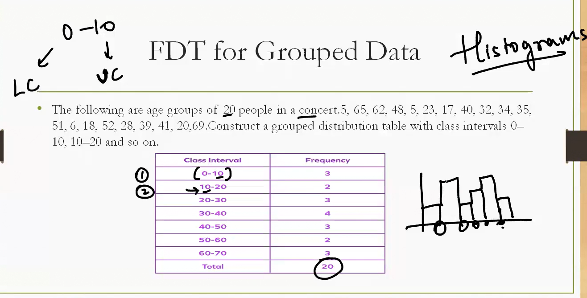

* Grouped data is basically when you create intervals or binning or create a different category.

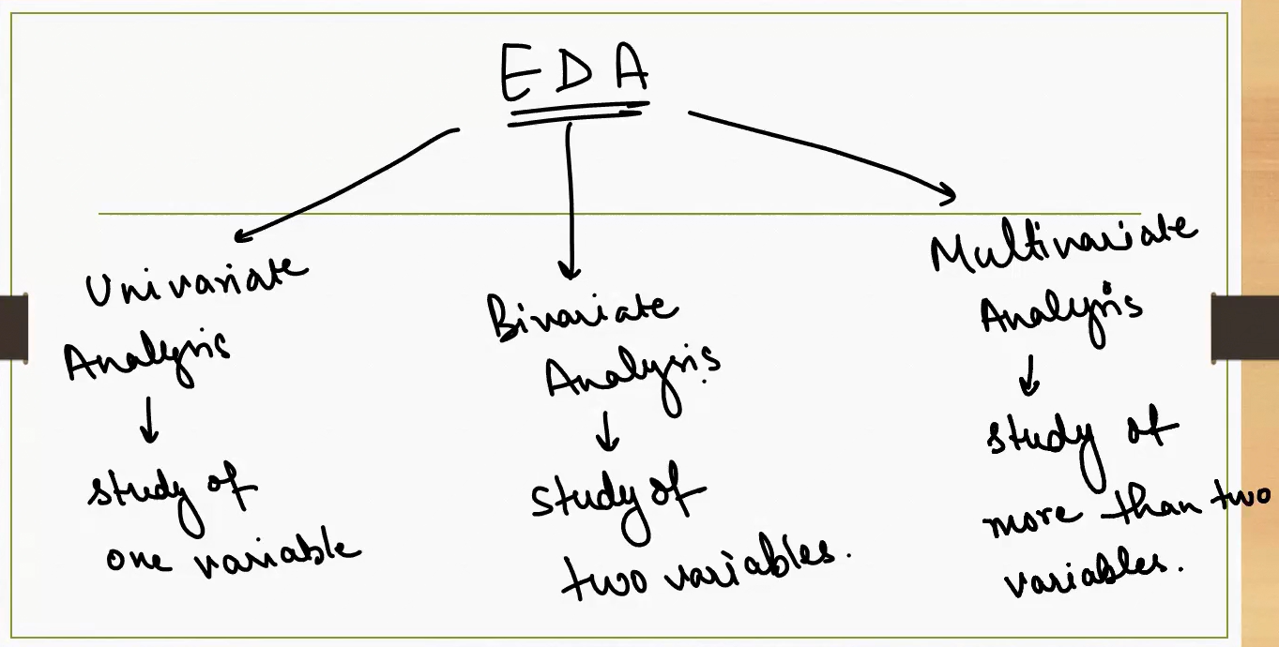

Three core types of **Exploratory Data Analysis (EDA)** — the process of examining datasets to uncover patterns, spot anomalies, test hypotheses, and check assumptions. Each type depends on how many variables you're analyzing:

**🔍 1. Univariate Analysis**

* **Focus**: One variable at a time.
* **Goal**: Understand distribution, central tendency, and spread.
* **Tools**: Histograms, box plots, mean, median, mode, variance.
* **Example**: Analyzing students' exam scores to see average performance and outliers.

**🔗 2. Bivariate Analysis**

* **Focus**: Two variables.
* **Goal**: Explore relationships or correlations.
* **Tools**: Scatter plots, correlation coefficients, cross-tabulations.
* **Example**: Studying the relationship between study hours and exam scores.

**🌐 3. Multivariate Analysis**

* **Focus**: Three or more variables.
* **Goal**: Understand complex interactions and patterns.
* **Tools**: Heatmaps, pair plots, PCA (Principal Component Analysis), regression models.
* **Example**: Predicting student performance using study hours, attendance, and IQ.

**🧠 Why It Matters**

* **Univariate** helps you understand each variable’s behavior.
* **Bivariate** reveals how variables influence each other.
* **Multivariate** uncovers deeper insights for modeling and prediction.

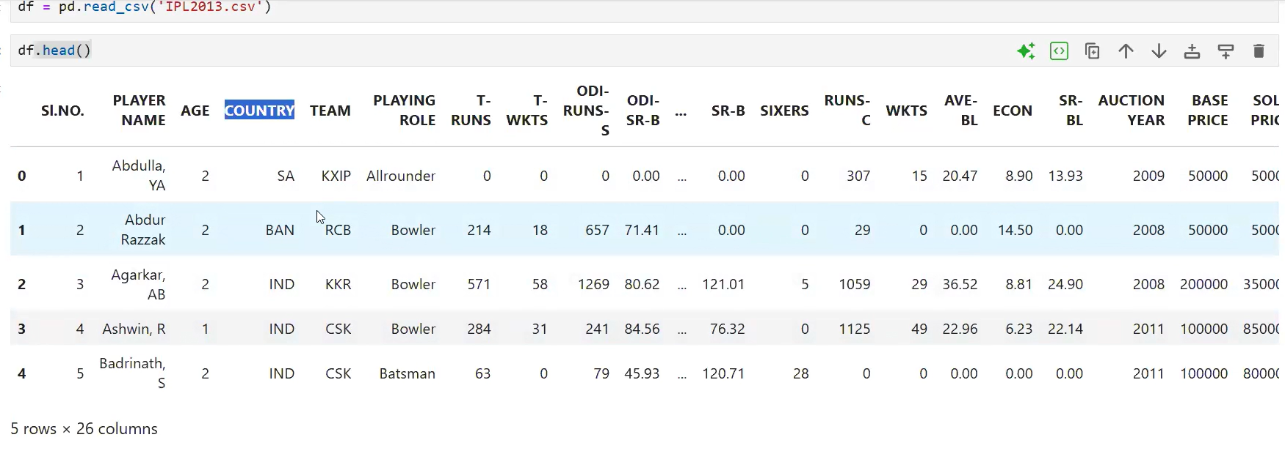

* Study is column separately is Univariate analysis,

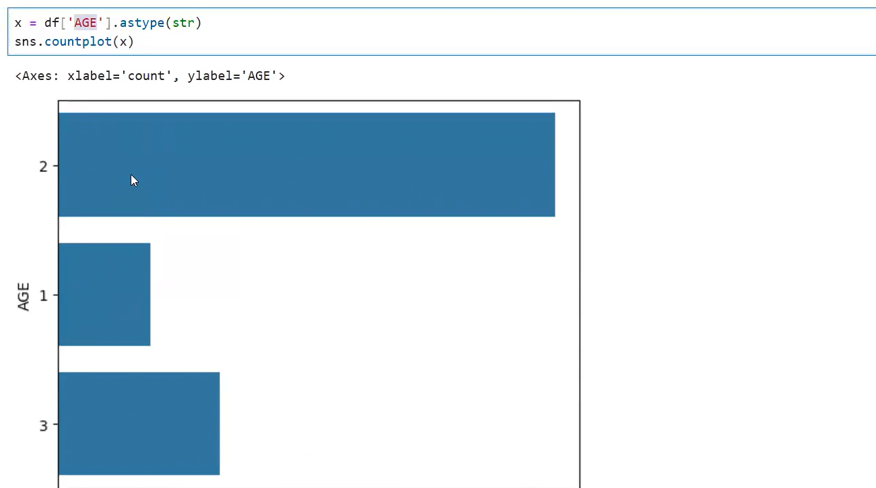

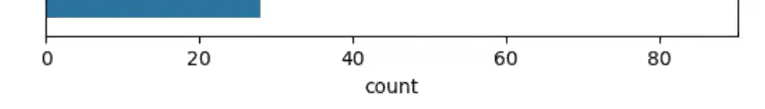

* Bivariate Analysis :

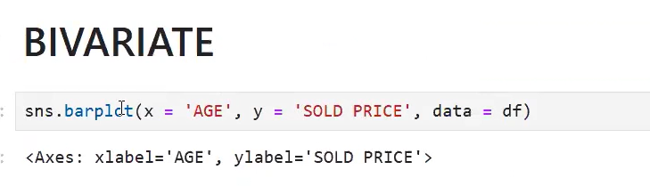

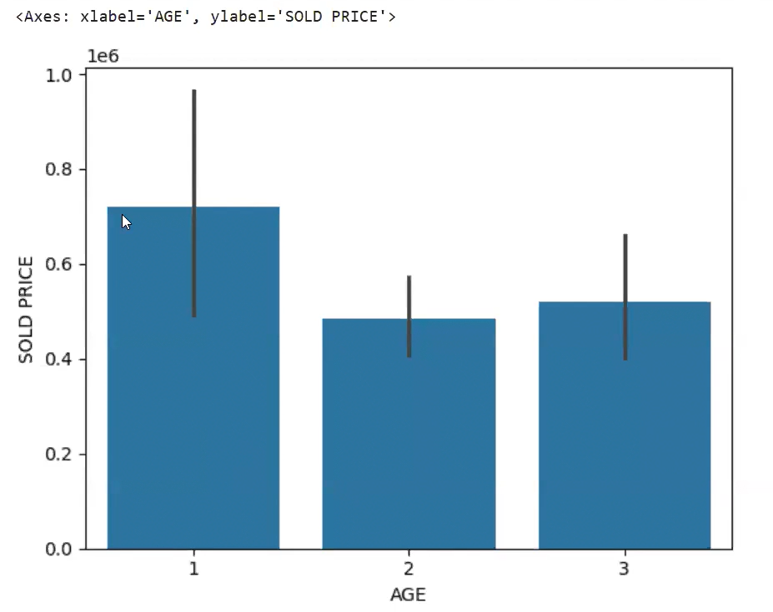

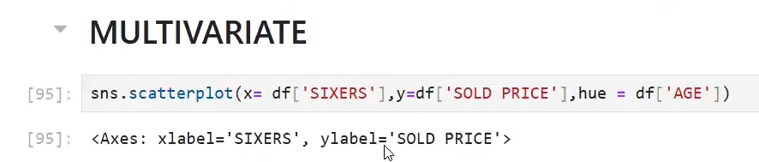

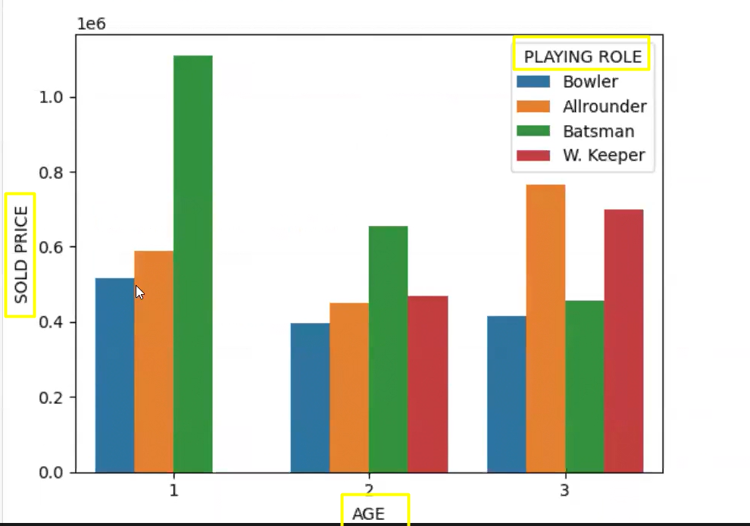

* More than 2 variables being studies so it is a multi-variate.

